ePortfolio copy and paste template for Graduate Diploma of Teaching (ECE) and Bachelor of Teaching ECE and Primary

Introduction
This template is designed to so you can create your own OneNote ePortfolio. There are a series of short video clips that will show you each step and can be used alongside this Word document to create your ePortfolio.
Anything in black font is to copy and paste, anything in red font an instruction to follow.
When you have created your ePortfolio, it will look something like the image below.

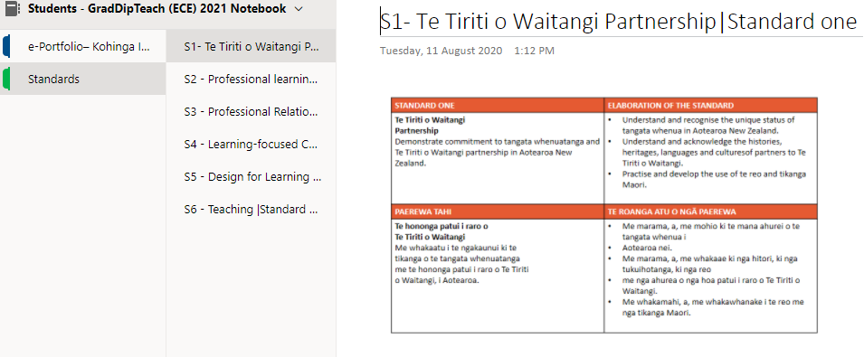

Where to start?
Watch the ‘step one, create your ePortfolio’ video in your programme page in PMA or click this link.
https://vimeo.com/522612257/e04b7520fe
The steps are as follows
- Go to the student landing page and login https://teritomaiohanz.sharepoint.com/sites/StudentLandingPage
- Go to the App Launcher or ‘waffle’ menu in the top left corner and open OneDrive
- Select the dropdown on the ‘new’ button and select folder, name the folder ePortfolio
- Open the new ePortfolio folder and then select the dropdown on the ‘new’ button and select OneNote Notebook
- Name the notebook using your name ePortfolio i.e. Dawns ePortfolio
Step one is now complete, go to step two.

Step two
Watch the next video for step two https://vimeo.com/522654467/c39cbbc8d3
The steps are as follows
- Select the first title below (a.) and copy the text
- Go back to your ePortfolio and right click on the first section, select rename and paste to replace the name
- Go to the heading area of the page in the first section and right click and paste
- Go to the next area of black text (b.) and copy this
- Go back to your ePortfolio and past this under the heading in the first page
- Scroll down this document and click on the link to download a copy of Our Code Our Standards, save this to your computer
- Go back to your ePortfolio and select the insert tab, place the cursor on the page where you want to insert the Our Code Our Standards file
- Click on the file drop down arrow and select insert print out
- Browse to where you saved the Our Code Our Standards file and select it and insert this as a print out.
a. Title for the first section AND the page in the first section
e-Portfolio– Kohinga Ipurangi Ako
b. copy and paste this into the first page in the first section
Your e-Portfolio is a tool to collect evidence of your work during your study with Te Rito Maioha. For example, assessments including text, video, graphics, teaching practice projects etc.

Materials should be organised to align with the six standards from Our Code Our Standards in a way that can showcase your work and synthesise your learning over time.

These standards are the criteria determined by the New Zealand Teaching Council.

You are required to keep a range of examples of evidence from all courses in your e-portfolio.

You will also be able to use your collection of work to support you with the Culminating Integrative Assessment CIA) and as evidence towards gaining Teacher Certification at the completion of your study.

c. Download a PDF of Our Code Our Standards and save on your computer, then from the insert tab on OneNote, select the file dropdown and select insert file printout.
https://teachingcouncil.nz/assets/Files/Code-and-Standards/Our-Code-Our-Standards-Nga-Tikanga-Matatika-Nga-Paerewa.pdf
Browse to the location where you saved the Our Code Our Standards and select the file.
This will print the file to the page.
This section is now complete

Step 3 Copying the template into the pages
Watch the video here https://vimeo.com/523300548/7110df2758 (41 seconds)
From your ePortfolio
- Click on Add section - call this section
  - Standards if you are studying in a one-year programme
  - or Stage one if you are studying a three-year programme
If you are studying a three-year programme you will need to add two more sections, call the second one Stage two and the third Stage three
In the new Standards (stage one) Section – select Add page, you need to add 6 pages, one for each standard

Adding the pages and the content
Watch the video here https://vimeo.com/523300574/06872d3811 (3 mins and 33 seconds)
Section two - Page one title – copy and paste
S1- Te Tiriti o Waitangi Partnership|Standard one
Image – copy and paste
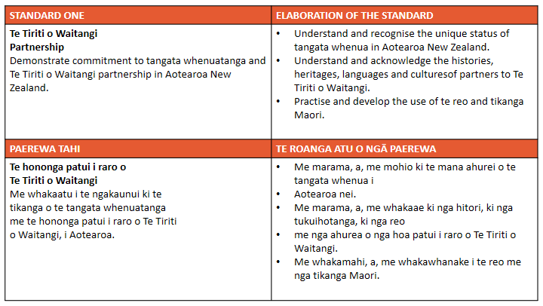

Section two - Page two title copy and paste
S2 - Professional learning|Standard two
Image – copy and paste
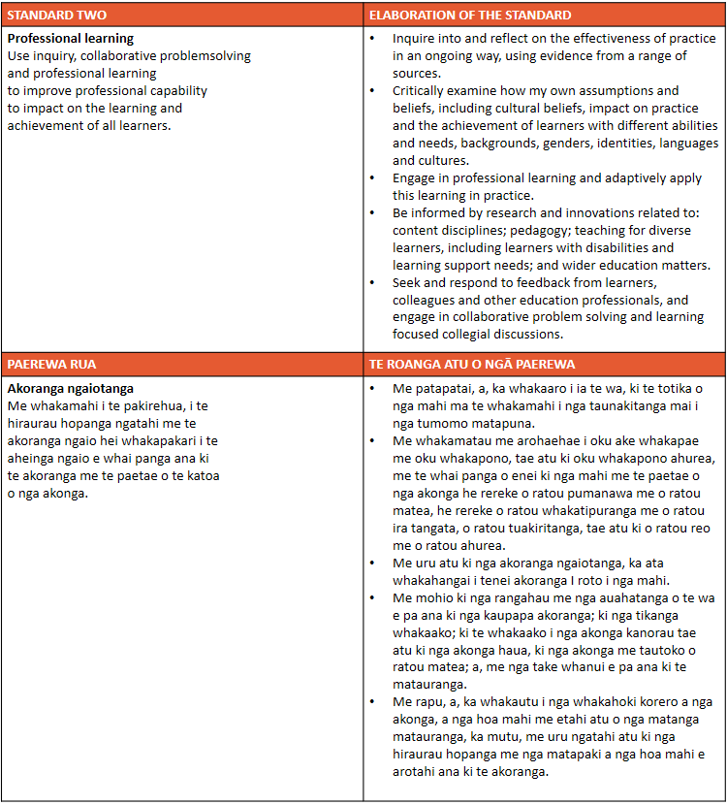
Section two - Page three title
S3 - Professional Relationships|Standard three
Image – copy and paste
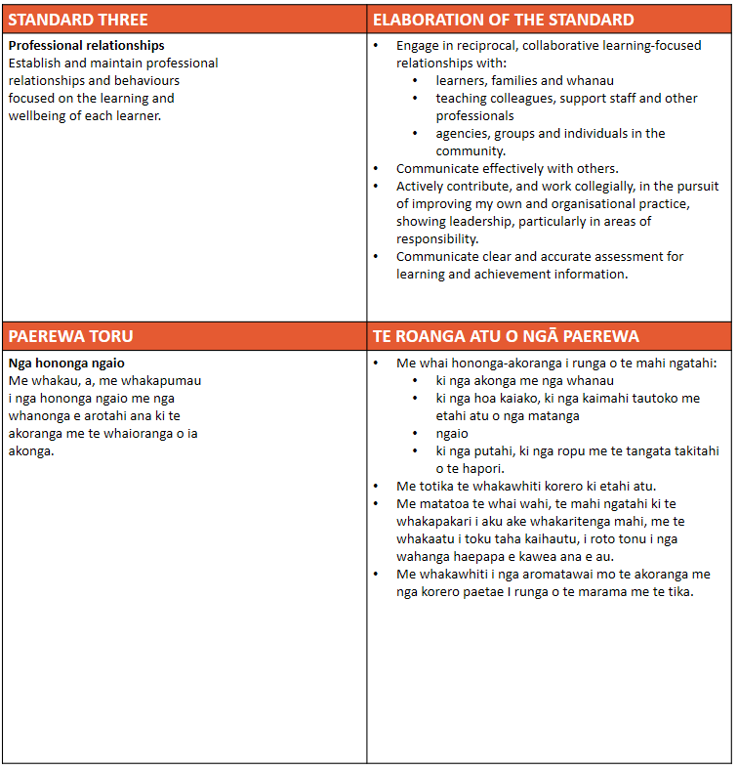
Section two - Page four title
S4 - Learning-focused Culture|Standard four
Image – copy and paste
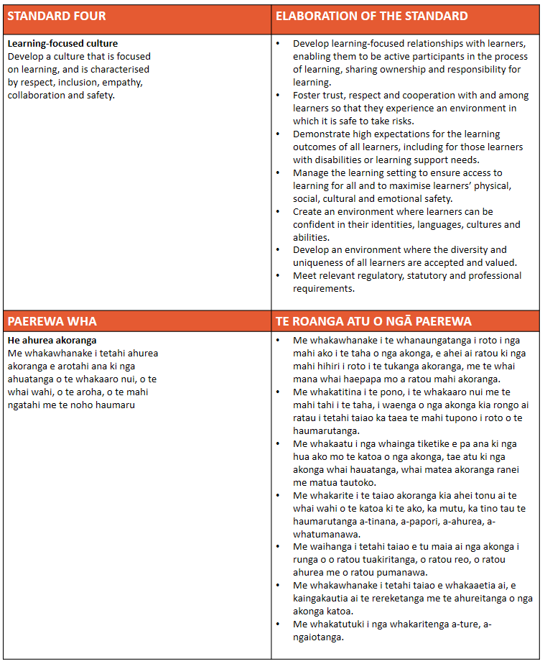
Section two - Page five title
S5 - Design for Learning |Standard five
Image – copy and paste
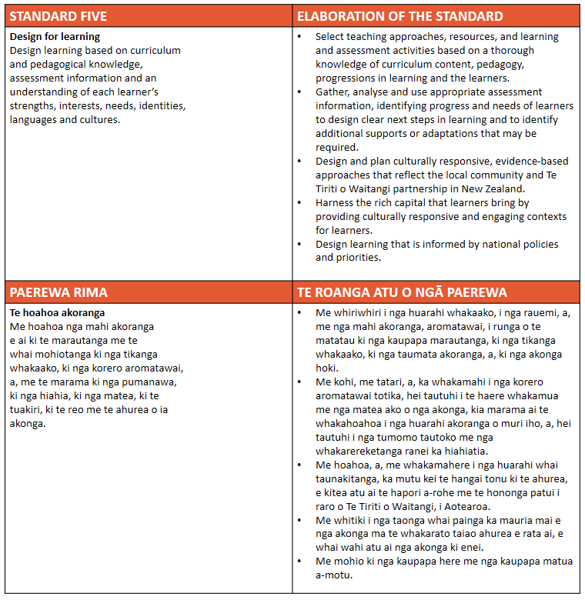
Section two - Page six title
S6 - Teaching |Standard six
Image – copy and paste

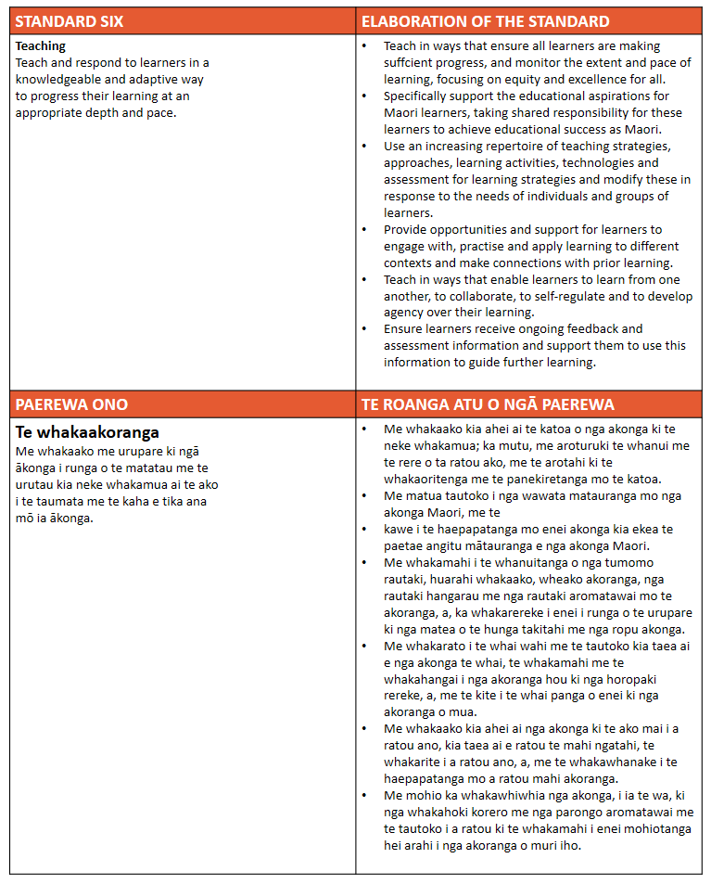
The end result should look something like this for a one year programme. See the next steps if you are studying a 3 year programme.

If you are studying in a three year programme, you should have created a section for each stage.
You will need to copy the pages from the first section (Stage one) into the Stage two and Stage three sections.
To do this go to the Stage one section and
- Click on the first page
- Right click on the first page and select copy
- Go to the stage two section and right click and select paste
- Repeat steps 1 – 3 until all pages have been copied into the stage two section
- Repeat again for the stage three section for all six pages.
Note: you can right click and delete any unwanted pages.
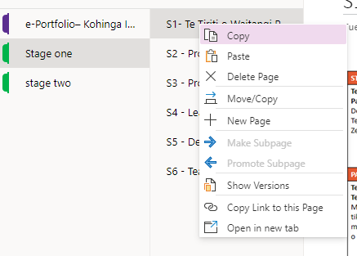
Click on the stage two section – right click in the first page in this section and select paste
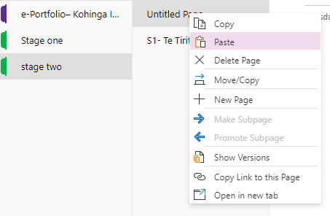
Your template is now complete, you can start to use your ePortfolio.
You may also be interested in downloading the mobile App to your smartphone – see video four to explain.
https://vimeo.com/523300612/819ecfd661

